Rhizina Root Disease (Rhizina undulata) DRR
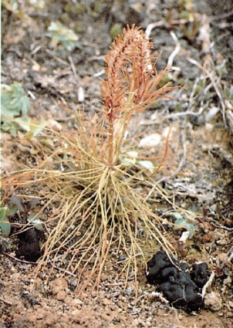
Low to Very Low priority

Description
Rhizina is a fungal pathogen with an above ground fruiting body. Seedlings of all native conifers are susceptible. Rhizina generally occurs during the two years following a wildfire or a prescribed burn, and tends to cause patchy mortality, with rates as high as 80%.

Extent
The risk of plantation failures due to Rhizina root disease have all but disappeared due to a decrease in the use of broadcast burning for site preparation. Consequently, Rhizina is considered a very low priority forest health factor. The losses resulting from Rhizina are accounted for in the current operational adjustment factors (OAF 1).

Data

Tactics
- Incidence levels should continue to be monitored and their priority reassessed at the annual review stage.
- Avoid broadcast burning in the Interior Cedar Hemlock (ICH) biogeoclimatic zone.

